Detection of AI-Generated Arabic Text

Presented By:

Sohila Mohey Mahmoud

Abstract
This project presents a complete framework for detecting AI-generated Arabic text using machine learning and deep learning approaches. The Arabic Machine-Generated Text dataset, derived from The Arabic AI Fingerprint study, was preprocessed through extensive cleaning, normalization, and lemmatization steps to ensure high linguistic quality. Both lexical-based features (TF-IDF) and contextual embeddings (BERT) were extracted and used to train multiple models, including Logistic Regression, SVM, Random Forest, XGBoost, and Feedforward Neural Networks.
Experimental results showed that XGBoost with TF-IDF features achieved the best overall performance (Accuracy = 95.1%, F1 = 0.950), confirming the effectiveness of traditional models for structured textual features, while BERT embeddings improved generalization in neural architectures. The findings demonstrate clear stylistic and statistical differences between human-written and AI-generated Arabic abstracts and support the development of reliable Arabic AI-text detection tools.

Introduction
The rise of large language models (LLMs) has made it increasingly difficult to distinguish between human-written and machine-generated text. While extensive research exists for English, Arabic detection remains limited due to the language’s morphological richness, diverse dialects, and lack of annotated data. Detecting AI-generated Arabic text is crucial for maintaining academic integrity, combating misinformation, and ensuring content authenticity across digital platforms.
This project aims to design and evaluate an Arabic text-classification pipeline capable of identifying whether a text was written by a human or generated by an AI model. It combines stylometric analysis with machine-learning and deep-learning algorithms, comparing classical lexical representations (TF-IDF) and modern contextual embeddings (BERT). The study also examines linguistic indicators—such as redundancy, short-word ratio, sentence length, and vocabulary richness—to highlight measurable stylistic differences between human and AI writing styles. Through this framework, the project contributes to advancing Arabic NLP research and developing practical tools for AI-text detection.

Related Work

The Arabic AI Fingerprint: Stylometric Analysis and Detection of Large Language Models Text (arXiv)
The paper “The Arabic AI Fingerprint” (2025) analyzes Arabic texts generated by models like ALLaM, Jais, LLaMA, and GPT-4, revealing clear linguistic patterns such as lower lexical diversity. BERT-based detectors achieved up to 99.9% F1-score in academic settings but struggled across domains. The dataset from that study forms the basis for this project’s experiments in Arabic AI-text detection and stylometric analysis.

Human vs. Machine: A Comparative Study on the Detection of AI-Generated Content (ACM)
The study focuses on detecting LLM-generated (DeepFake) text using transfer learning on pre-trained models, achieving 94–99% accuracy, surpassing human detection ability. It emphasizes the need for automated authenticity checks and aligns with this project’s goal of distinguishing human-written and AI-generated Arabic text through stylometric and deep-learning methods.

ALHD: A Large-Scale and Multigenre Benchmark Dataset for Arabic LLM-Generated Text Detection (arXiv)
The ALHD dataset is a large Arabic corpus (400K+ samples) distinguishing human and LLM-generated texts across news, social media, and reviews in both MSA and dialects. Fine-tuned BERT models outperformed larger LLMs but struggled with cross-genre generalization. Like this project, it advances Arabic AI-text detection—though this work focuses specifically on academic abstracts using stylometric analysis.

Dataset Description
The Arabic Machine-Generated Text Dataset is a specialized corpus designed to support research on detecting and analyzing Arabic texts generated by Large Language Models (LLMs). It was introduced in the study “The Arabic AI Fingerprint: Stylometric Analysis and Detection of Large Language Models Text” (https://arxiv.org/abs/2505.23276). The dataset aims to enable stylometric analysis, cross-model generalization, and the development of Arabic AI-text detection systems.
The dataset contains 8,388 samples of Arabic academic abstracts produced through three main generation methods:
- by_polishing – refining existing human abstracts (2,851 samples),
- from_title – generating abstracts from titles only (2,963 samples), and
- from_title_and_content – generating text using both title and paper content (2,574 samples).
Each entry includes a human-written abstract (original_abstract) and corresponding AI-generated versions from several models: ALLaM (7B), Jais (70B), Llama 3.1 (70B), and OpenAI GPT-4. The dataset focuses on Modern Standard Arabic (MSA) academic abstracts collected from the Algerian Scientific Journals Platform (ASJP), covering publications from 2010 to 2022 to ensure data authenticity from the pre-AI era. Human abstracts average around 120 words, while generated ones vary between 62–165 words, depending on the model and generation method.
Data were collected and processed using automated web scraping and text extraction from PDFs. Metadata (titles, journals, publication dates, abstracts) were extracted, and multilingual abstracts were segmented using rule-based and statistical methods. Preprocessing included Unicode normalization, removal of formatting artifacts, and filtering of low-quality or incomplete texts. Scripts and processing tools are publicly available at https://github.com/KFUPM-JRCAI/arabs-dataset.
From the research findings, LLM-generated texts exhibited lower vocabulary diversity and distinct frequency patterns, forming identifiable linguistic fingerprints for each model. The dataset supported detection models that achieved up to 99.9% F1-score, with strong cross-model generalization (86–99.9%) and near-perfect precision in identifying AI-generated content.

Methodology

Data Preparation and Preprocessing
The Arabic textual data were collected, cleaned, and standardized through a comprehensive Python pipeline. This stage included removing duplicates, handling missing data, normalizing Arabic characters, removing diacritics, and applying stopword removal and lemmatization.
Multiple cleaning modes were implemented — basic preprocessing, advanced normalization, and lemmatization — to ensure data consistency and preserve semantic meaning.

Feature Engineering
Several linguistic and structural features were extracted to enrich the dataset and improve classification accuracy. These include:
- Short Word Ratio (N): proportion of short words (≤3 letters) in each text.
- Total Number of Lines (L): counts the number of text lines.
- Number of Foreign Letters: measures non-Arabic character frequency.
- Number of Active Voice Sentences: detected using dependency parsing in Stanza.
- Redundancy Score: evaluates textual repetition using TF-IDF weights.
These features provided quantitative insights into text complexity, linguistic diversity, and stylistic patterns.

Modeling
A set of machine learning and deep learning algorithms was implemented to classify Arabic texts into their respective categories.
Models were organized as follows:
- Baseline Models: Logistic Regression and Naïve Bayes.
- Traditional ML Models: Support Vector Machine (SVM), Random Forest, and XGBoost.
- Deep Learning Models: Feedforward Neural Network (FFNN) and a Simple DNN.
Each model was trained using both TF-IDF and BERT embeddings to compare lexical-based versus context-aware representations. All models were trained on the training split, tuned on validation, and evaluated on a held-out test set using Accuracy, Precision, Recall, F1-score, and ROC-AUC metrics.

Results & Analysis

Data Cleaning and Preprocessing
The dataset used in this study was compiled from multiple Arabic text sources containing both human-written abstracts and AI-generated ones. All subsets were concatenated into a single DataFrame and reshaped into a unified long format using pandas.melt, producing a clean structure with two main columns: category and text. The initial combined dataset contained 41,940 rows and two columns before cleaning. An early inspection confirmed that no missing values existed, yet 5,399 duplicate rows were detected. These duplicates were removed to prevent data leakage and redundancy, resulting in a refined dataset containing 36,525 unique rows.
A binary encoding process was then applied to simplify classification, creating a new column named category_encode. In this column, original (human-written) abstracts were labeled as 1, and generated (AI-produced) texts were labeled as 0. After encoding, the class distribution indicated that 33,549 samples (91.8%) were generated and 2,992 samples (8.2%) were original. This imbalance reflected the dataset’s composition, as AI-generated content dominated across the collected corpora. Prior to cleaning, all five text sources (Original, Allam, Jais, LLaMA, and OpenAI) were nearly balanced, each representing around 20% of the data. However, after removing duplicate and low-quality entries, generated samples became the majority because most of the repeated or similar entries originated from AI models rather than human-written abstracts.
A detailed data-quality assessment was carried out to ensure the reliability of the corpus. All text entries were validated as Arabic strings, with no null values, no excessively short fragments, and no irregular or non-Arabic symbols. The inspection confirmed the dataset’s structural consistency, ensuring readiness for the subsequent text preprocessing pipeline.
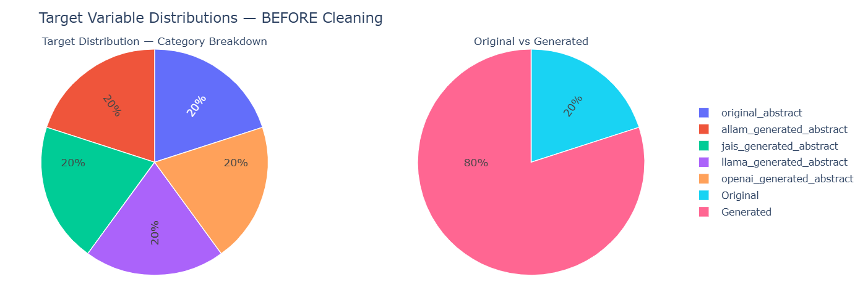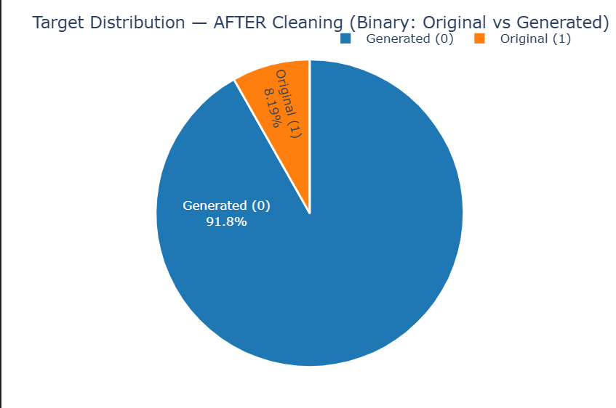

Arabic Text Preprocessing
The Arabic text preprocessing stage was divided into two main phases: basic normalization and advanced text cleaning.
In the first phase, normalization was performed by unifying Arabic letter forms (for example, converting أ / إ / آ → ا, ى → ي, and ة → ه), removing diacritics, and deleting non-Arabic symbols and digits. Tokenization was applied, followed by the removal of common Arabic stopwords using the NLTK library. Each text was then stemmed using the ISRI stemmer to reduce words to their morphological roots, while a separate lemmatized version was created using the Stanza library to retain grammatical meaning.
In the second phase, additional cleaning operations were introduced to remove HTML tags, URLs, email addresses, numbers, and repeated punctuation marks. Character elongation was also normalized, and extra whitespace was eliminated to ensure textual consistency. This stage produced a highly standardized version of the Arabic text, suitable for feature extraction using both TF-IDF and BERT embedding techniques. The fully processed dataset was then saved as processed_dataset.csv to maintain reproducibility and facilitate subsequent modeling tasks.

Statistical Analysis
The statistical analysis examined key linguistic features, including average word length, sentence length, and vocabulary richness (Type–Token Ratio). Results showed clear differences between human-written and AI-generated abstracts. AI-generated texts (Allam, Jais, LLaMA, OpenAI) had shorter sentences of about 20–25 words, average word lengths near five characters, and moderate lexical diversity (TTR ≈ 0.70–0.79). In contrast, human-written abstracts were much longer (≈79 words per sentence) and slightly richer in vocabulary (TTR = 0.798), reflecting higher linguistic complexity. Overall, human texts appear more diverse and elaborate, while AI-generated ones are concise and uniform, a distinction that supports later model classification.
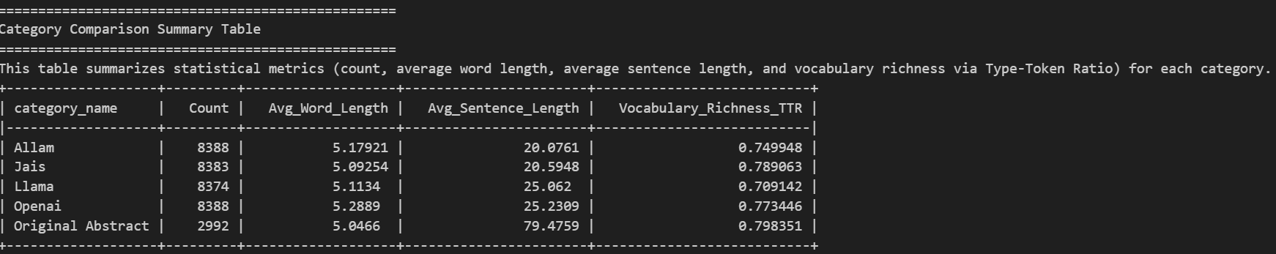

N-Gram and Word Cloud Analysis
The N-gram analysis was performed to identify the most frequent linguistic patterns in both AI-generated and human-written Arabic abstracts. The results show that AI-generated texts across Allam, Jais, LLaMA, and OpenAI models mainly repeat short academic phrases such as “بحث عن”, “هدف درس”, and “سلط ضوء على”, which reflect repetitive and formulaic sentence structures. In contrast, the original human-written abstracts include a wider range of verbs and connectors, indicating more complex and natural language use.
The word cloud visualizations further support these findings. The AI-generated groups are dominated by recurring words like “بحث”, “هدف”, and “دراسة”, while the original abstracts show more balanced distributions with diverse keywords such as “علم”, “فكر”, and “عمر”. This difference highlights that human writing is more varied and context-rich, whereas AI-generated text tends to rely on frequent template-like expressions.
Figures below present the Top N-grams and Word Clouds for each source (Allam, Jais, LLaMA, OpenAI, and Original Abstract).
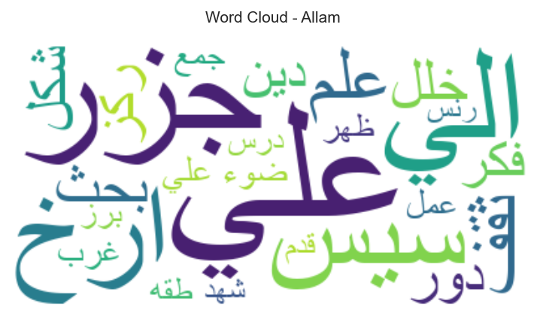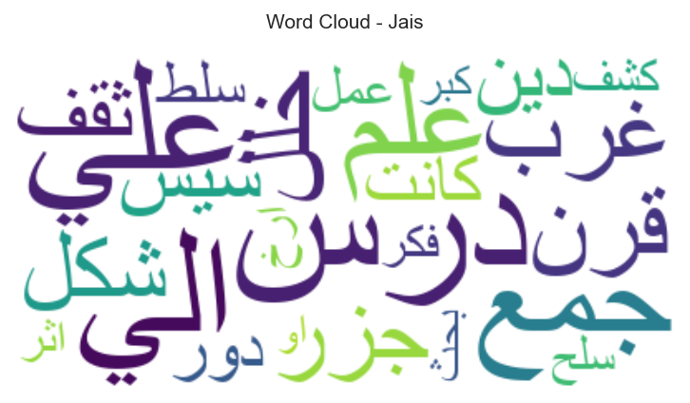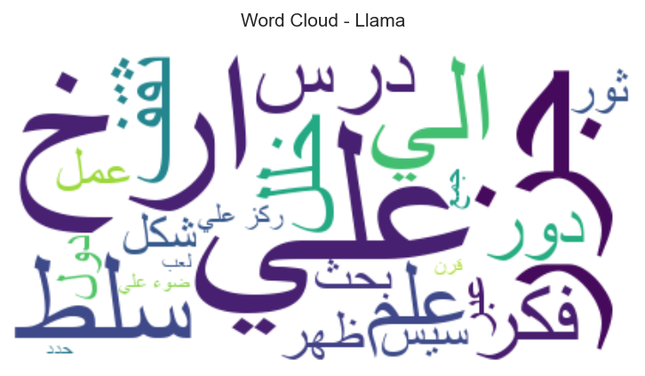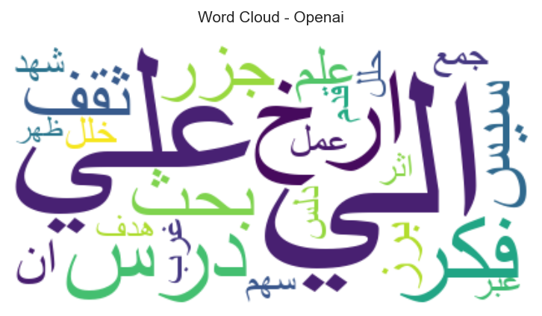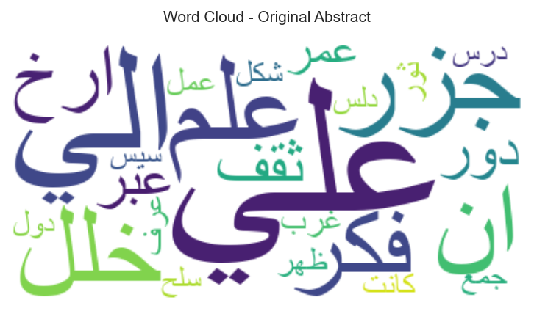
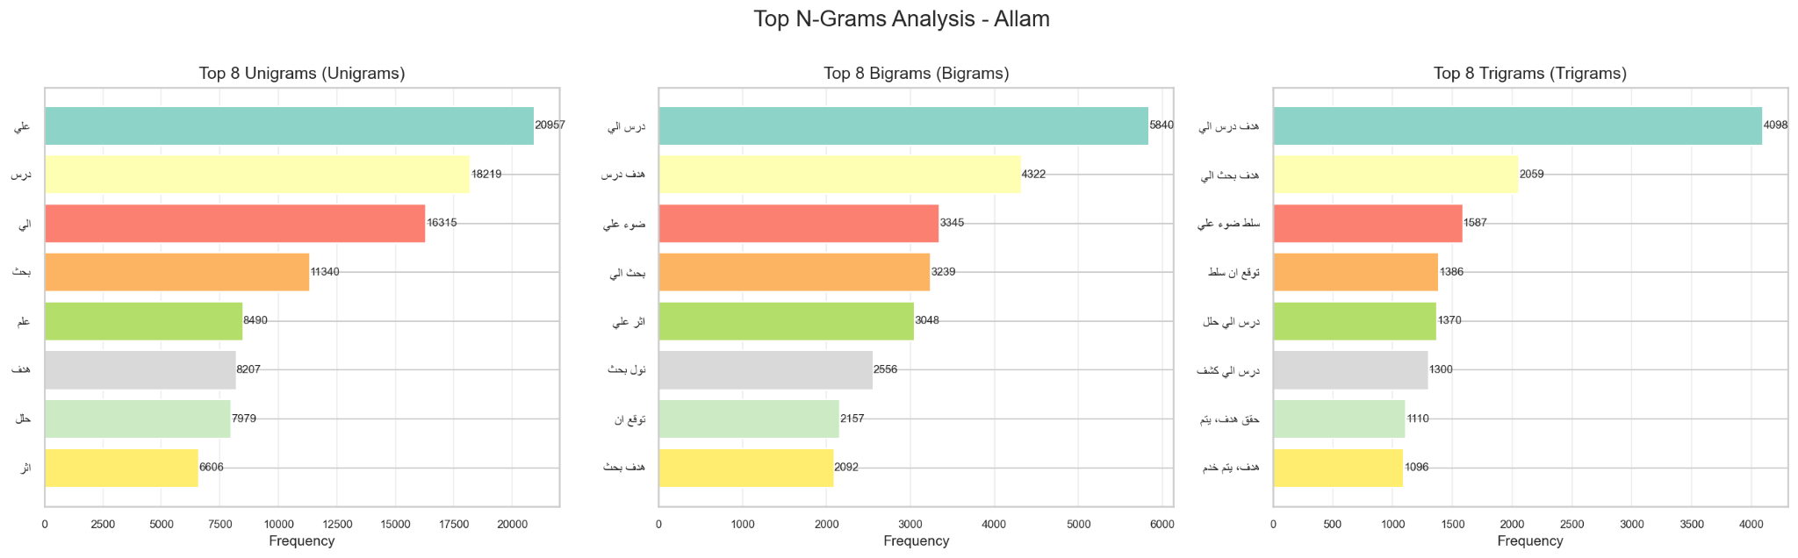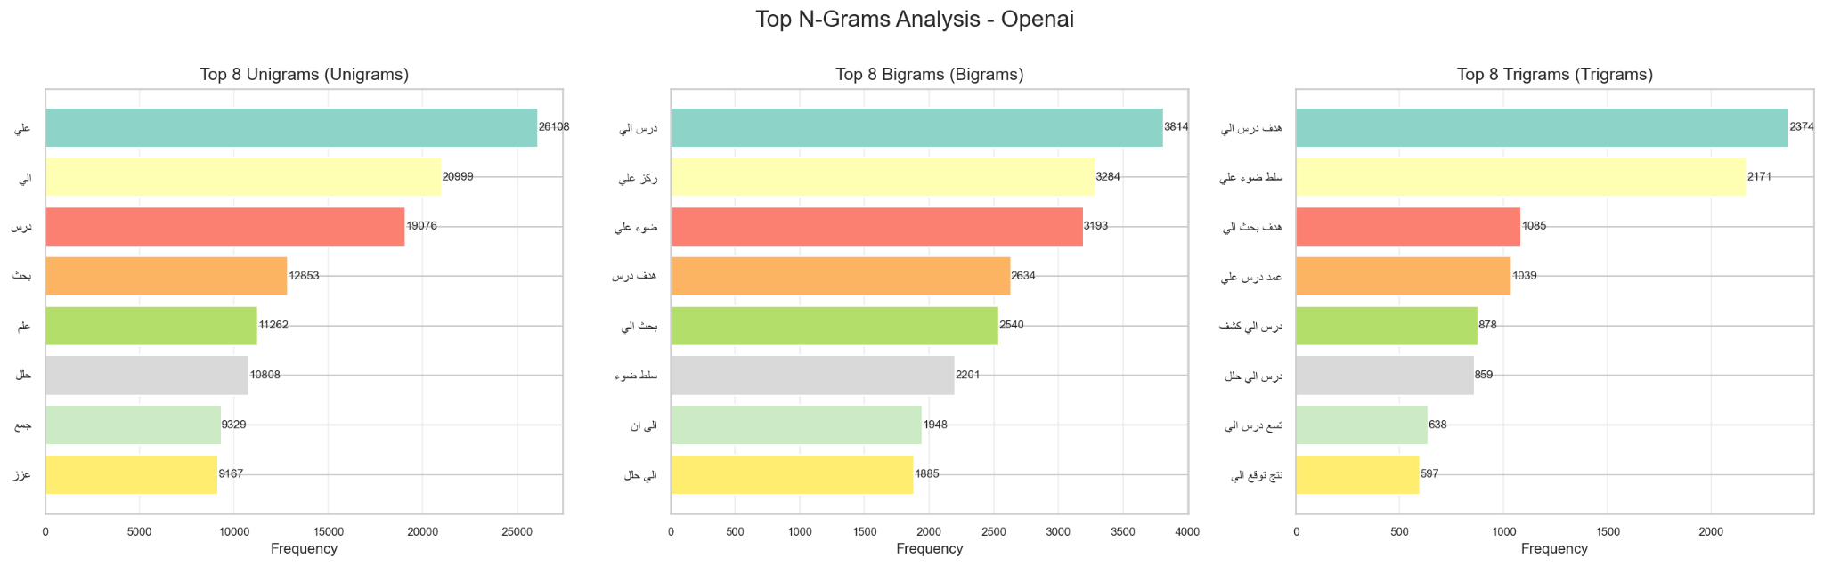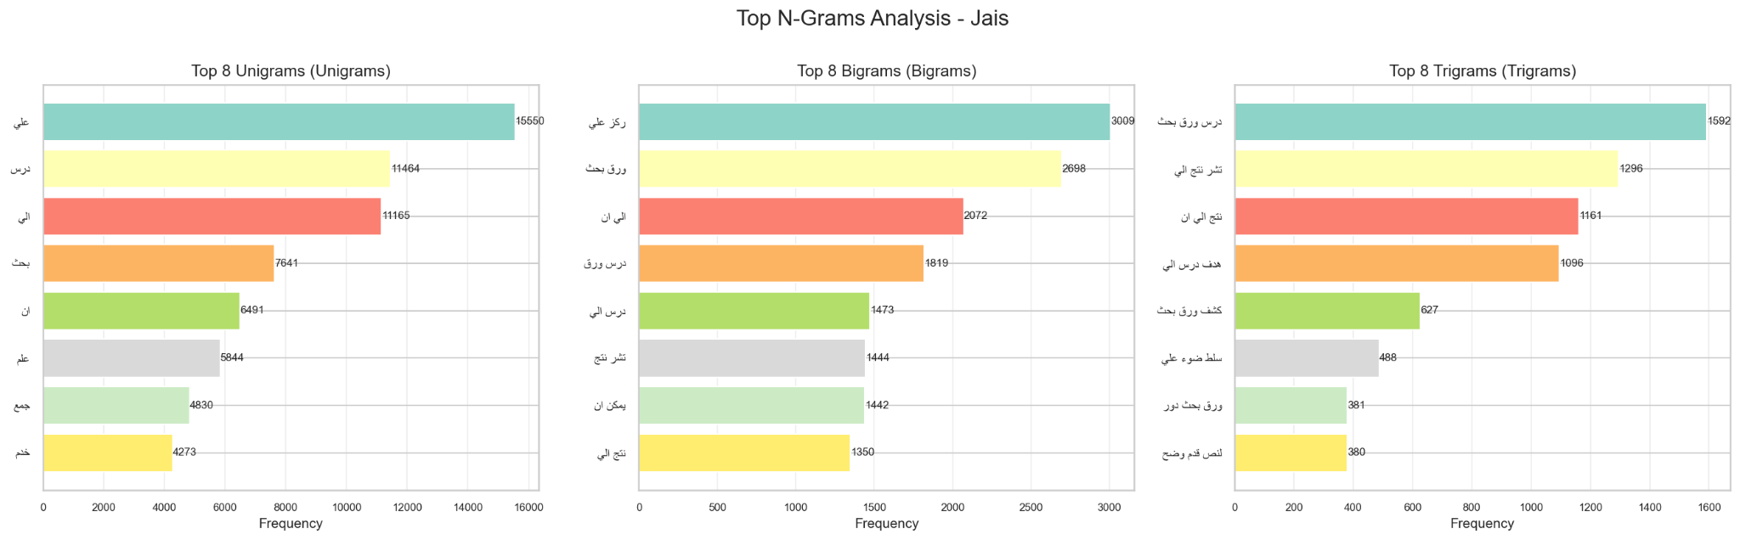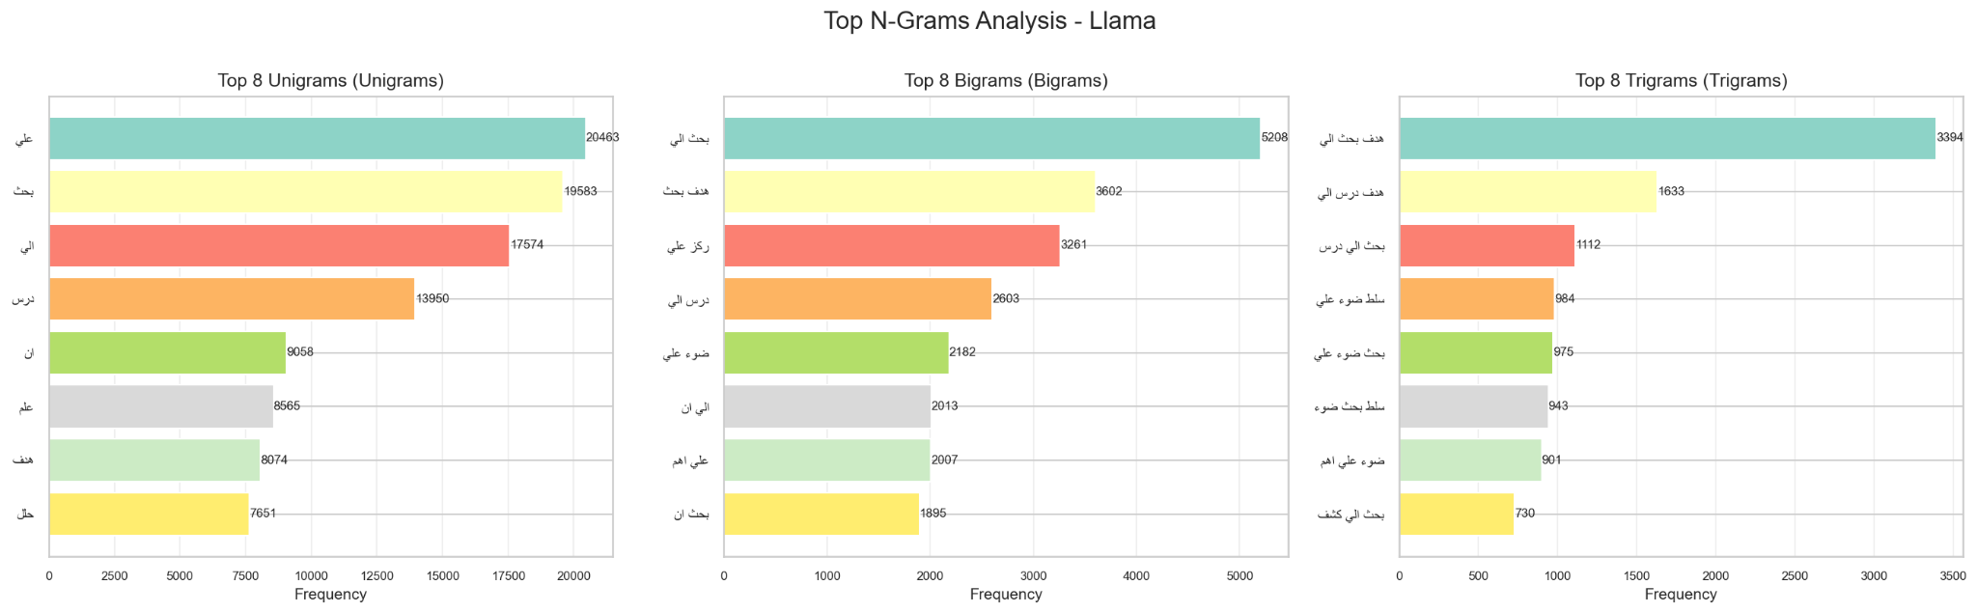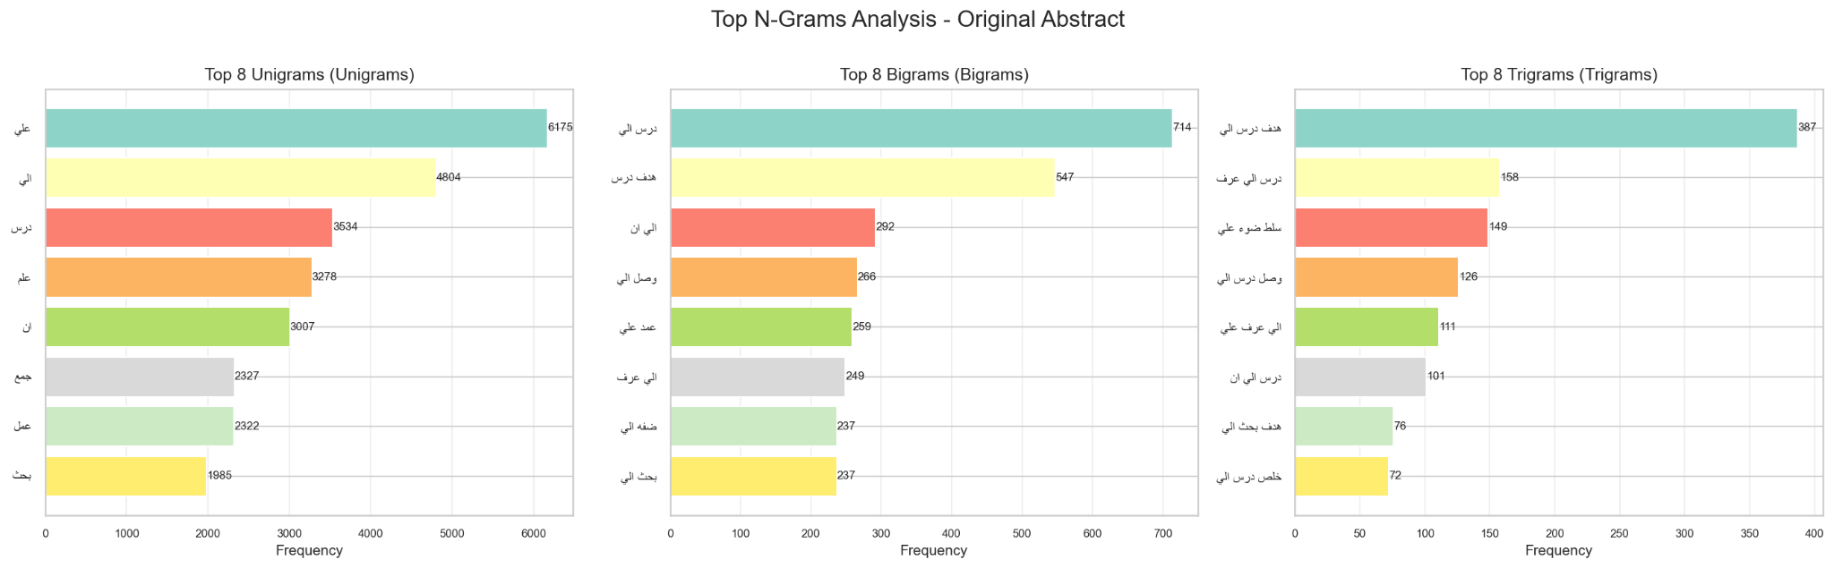

Lexical Analysis Summary
The lexical analysis examined how function words, punctuation marks, and specific Arabic terms are distributed across both AI-generated and human-written abstracts.
As shown in the summary visualization, OpenAI texts contained the highest number of total words and punctuation marks, while Original Abstracts used fewer overall but with more natural variation. The function word density (around 23–24 words per 1,000 characters) remained relatively stable across all models, but the punctuation density varied significantly — peaking in Jais (20.5 per 1,000 chars) and dropping in OpenAI (13.7 per 1,000 chars).
These differences indicate that AI-generated abstracts tend to overuse structural markers (such as “في”, “على”, “إلى”) and punctuation in patterned ways, whereas human-written abstracts employ punctuation and linking words more naturally and contextually. Overall, this reinforces that AI-generated language is more formulaic, while human writing remains more flexible and expressive.
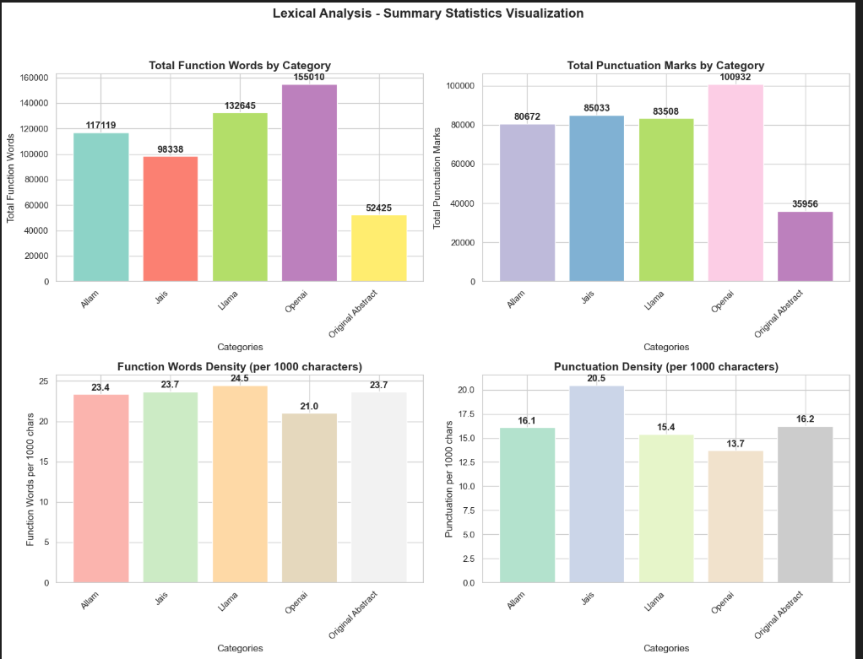

Feature Engineering

Short Words Ratio
The short-word feature measures the proportion of words with three letters or fewer in each abstract. Across the dataset (36,524 samples), the overall average ratio was 0.09, meaning short words made up roughly 9% of total tokens. Category-wise comparison showed that Jais (10.8%) had the highest short-word frequency, followed by Original (9.8%), Allam (9.7%), LLaMA (8.9%), and OpenAI (8.1%). Although differences are small, human-written and Jais-generated texts tend to include more short connective and functional words (e.g., “في”, “من”, “عن”), while OpenAI outputs favor longer, structured terms. This feature captures subtle stylistic and syntactic tendencies valuable for text classification.

Total Number of Lines (L) and Sentence Count
Across 36,524 cleaned texts, each abstract is stored as a single physical line (Average Lines = 1.0), so line count is non-discriminative. In contrast, sentence count varies meaningfully (overall mean = 5.79; total = 211,324 sentences). Human-written abstracts have the highest average sentences (7.43), followed by OpenAI 6.50, Jais 5.91, LLaMA 5.66, and Allam 4.49. Because lines are constant, the line-to-sentence ratio (≈ 1/Avg_Sentences) decreases with richer structure (lowest for Original at 0.13), confirming that human texts are more segmented and syntactically elaborate, while AI outputs—especially Allam—tend to be more concise. This justifies using sentence count (not physical lines) as a useful stylistic feature in downstream models.

Foreign Letters Ratio
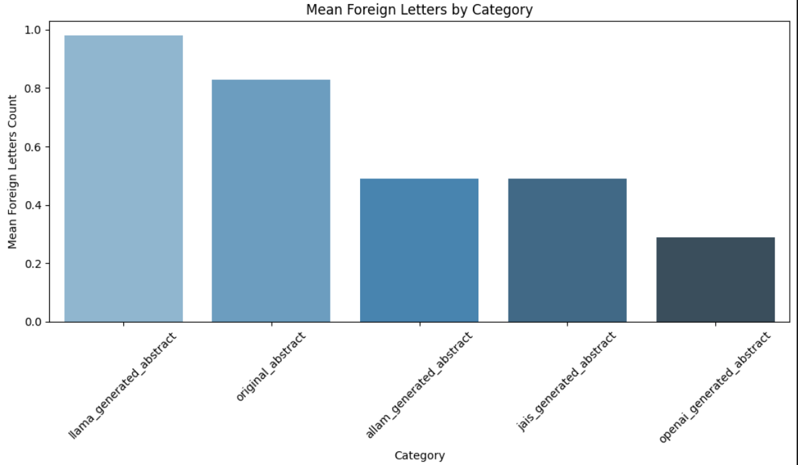
The foreign letter feature measures the presence of non-Arabic characters within each abstract. Across all 36,524 samples, the average count was low (mean = 0.58 letters per text), confirming that the dataset is almost entirely Arabic. However, minor variations were observed between categories: LLaMA (0.98) and Original (0.83) contained slightly higher foreign character frequencies—mainly due to English terms, symbols, or abbreviations—while Allam (0.49), Jais (0.49), and OpenAI (0.29) remained nearly pure Arabic. This indicates that human-written and some LLaMA-generated texts occasionally integrate foreign elements, offering a subtle but useful stylistic cue for model differentiation.

Redundancy Score
The redundancy score measures textual repetition based on TF-IDF similarity within each abstract. The overall mean score was 0.53, indicating moderate repetition across the corpus. AI-generated texts showed noticeably higher redundancy — Allam (0.56), LLaMA (0.55), Jais (0.54), and OpenAI (0.52) — while human-written abstracts had a much lower average (0.39). This suggests that AI models often reuse similar phrases or structures, whereas human authors write with greater lexical variation and syntactic diversity, making redundancy a strong stylistic discriminator in classification.

Model Development and Evaluation
The primary objective of this study was to perform Arabic text classification using a variety of traditional and deep learning models under two feature representation techniques: TF-IDF and BERT embeddings.
Overall, the experimental results demonstrate that TF-IDF features were highly effective for traditional machine learning algorithms, yielding superior performance in both accuracy and F1-score. For instance, Xgboost achieved an accuracy 95.11% with F1-Score 95.02%. Logistic Regression reached an accuracy of 94.36% and an F1-score of 0.946, while Random Forest reached 93.90% accuracy with an F1-score of 0.933. These models provided robust and interpretable results when applied to sparse lexical representations.
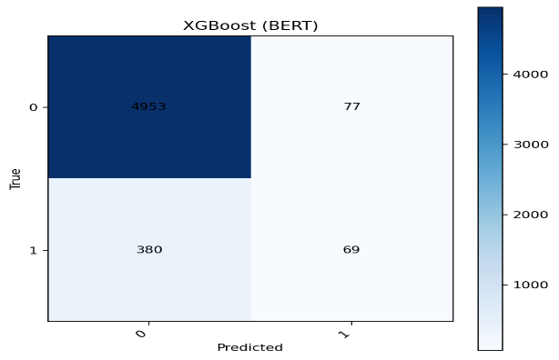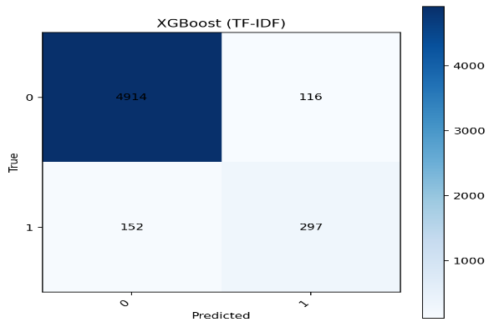
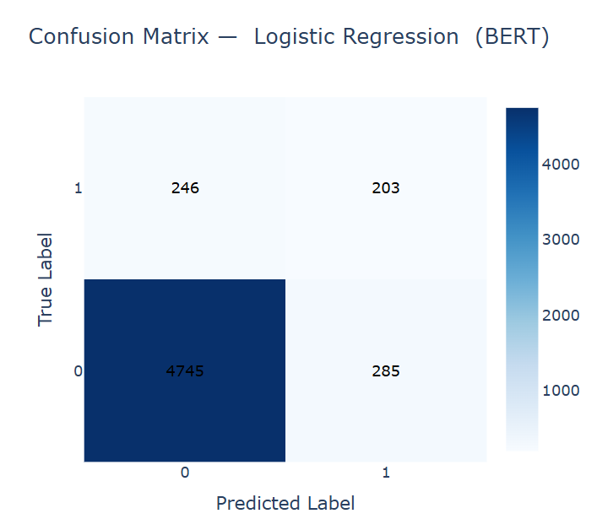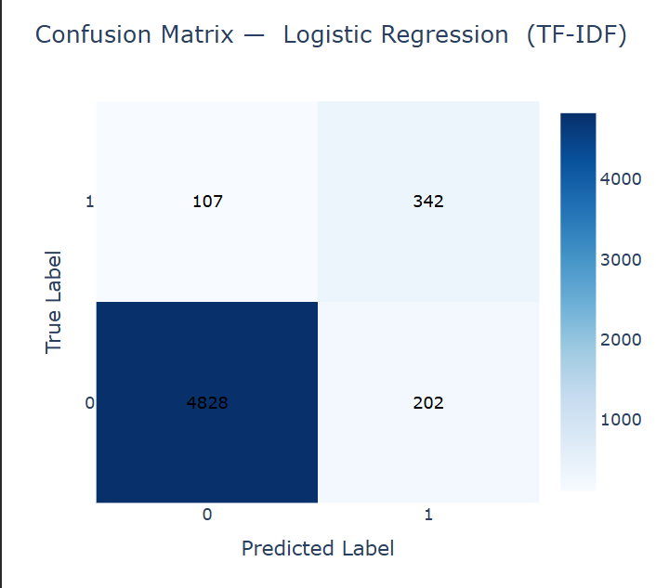

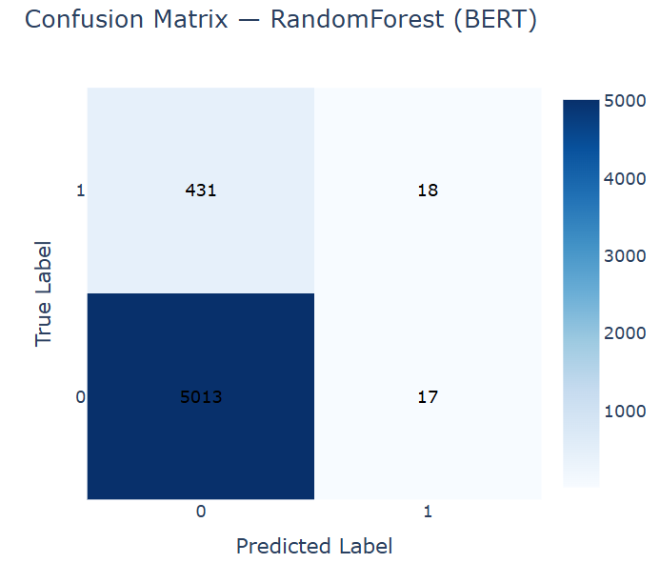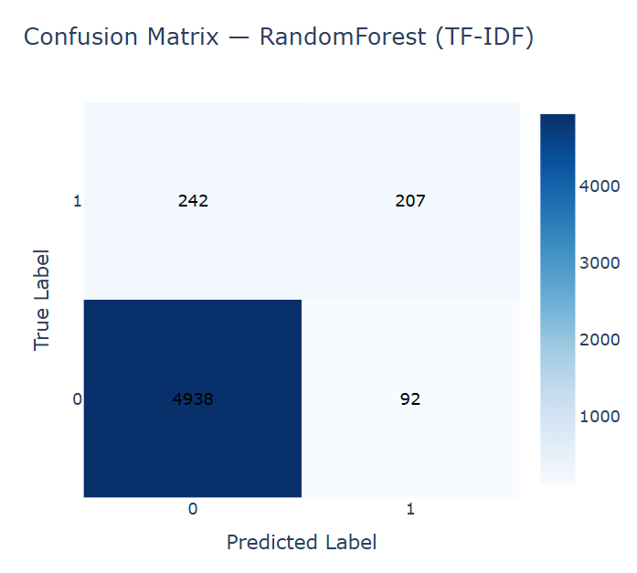
Similarly, the Support Vector Machine (SVM) model performed very competitively, achieving 94.10% accuracy and an F1-score of 0.934 using TF-IDF features. This highlights its robustness in handling high-dimensional text data and its ability to achieve consistent generalization compared to other classical algorithms.
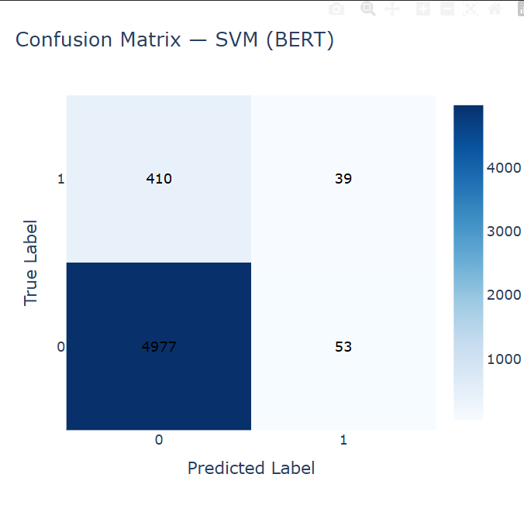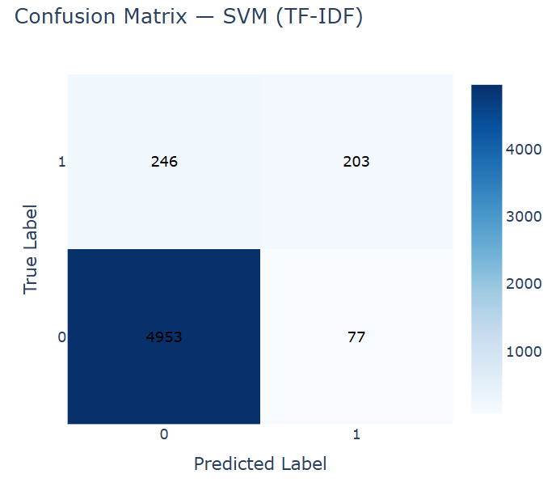
Conversely, BERT embeddings exhibited stronger generalization within deep learning architectures, where contextual and semantic understanding contributed to more consistent classification performance. The Feed-Forward Neural Network (FFNN) achieved an accuracy of 92.00%, while the Simple DNN attained 91.29%, confirming the advantage of contextual embeddings for capturing deeper linguistic relationships in Arabic text.
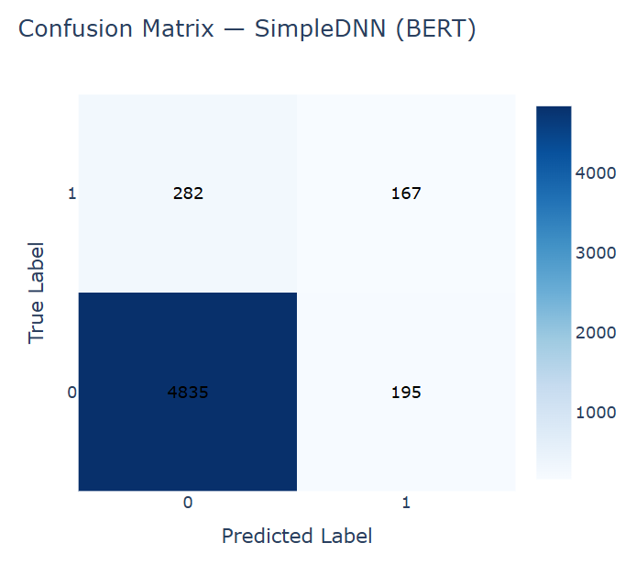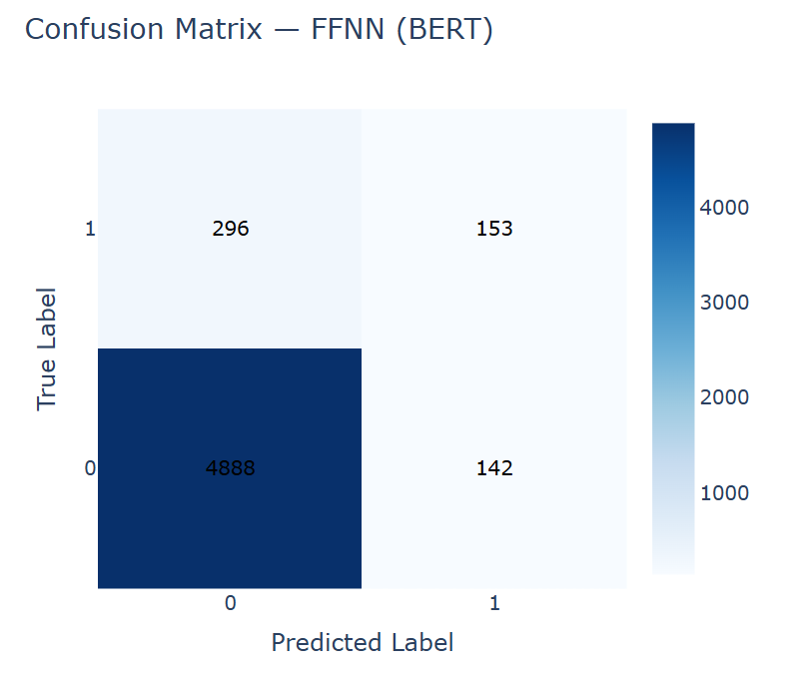
The Naïve Bayes model performed relatively poorly with BERT embeddings (Accuracy = 56.85%), due to its independence assumption, but achieved 90.01% accuracy when trained on TF-IDF features, highlighting its compatibility with simpler representations.
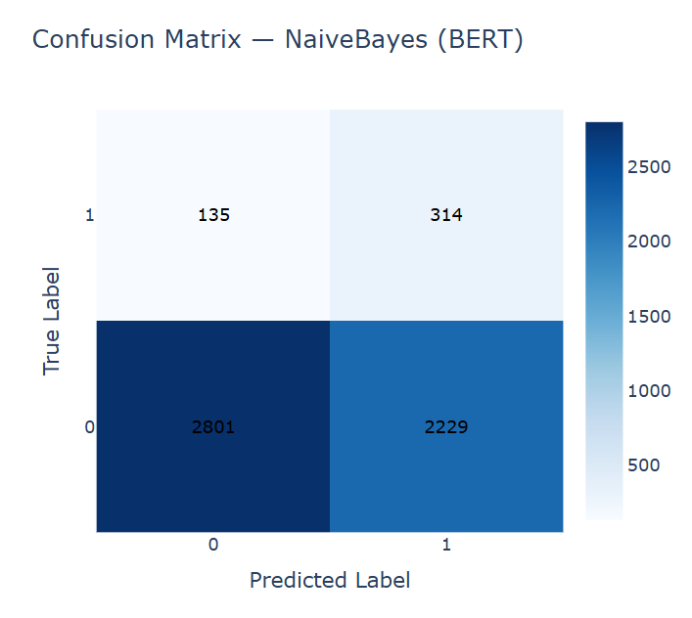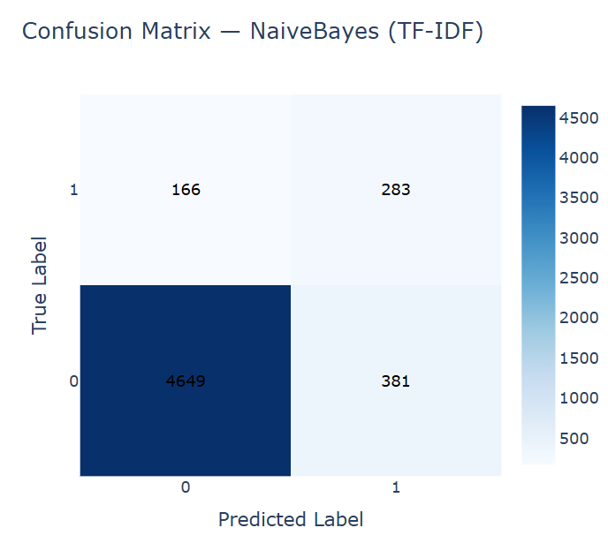
Among all evaluated models, XGBoost using TF-IDF produced the highest overall performance (Accuracy = 95.10%, F1-score = 0.950, ROC-AUC = 0.967), representing an optimal balance between efficiency, interpretability, and predictive power.
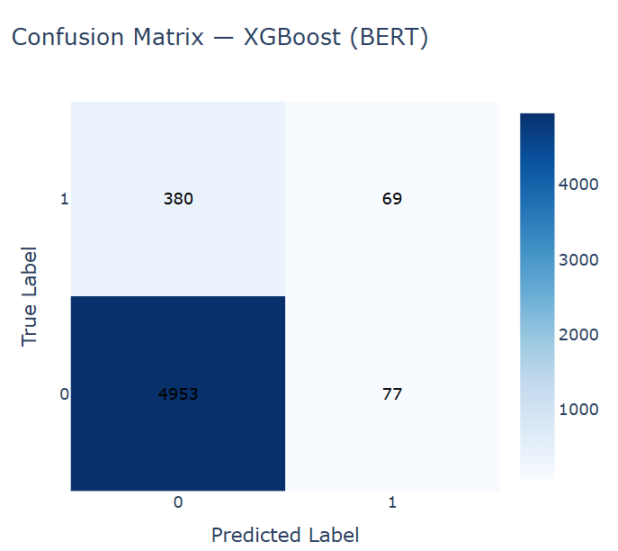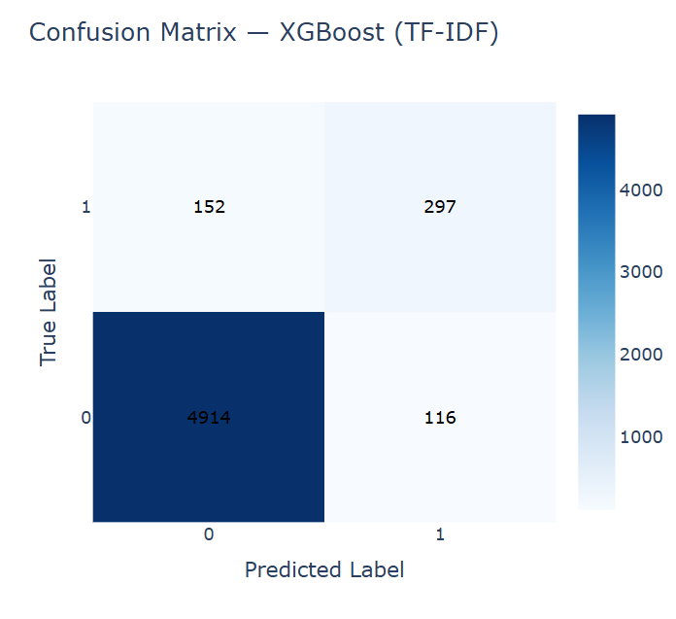
In summary, the findings confirm that TF-IDF representations remain highly suitable for classical models, whereas BERT embeddings are more advantageous for deep learning architectures. Together, these results provide a comprehensive benchmark for Arabic text classification and emphasize the complementary roles of lexical and contextual feature representations.
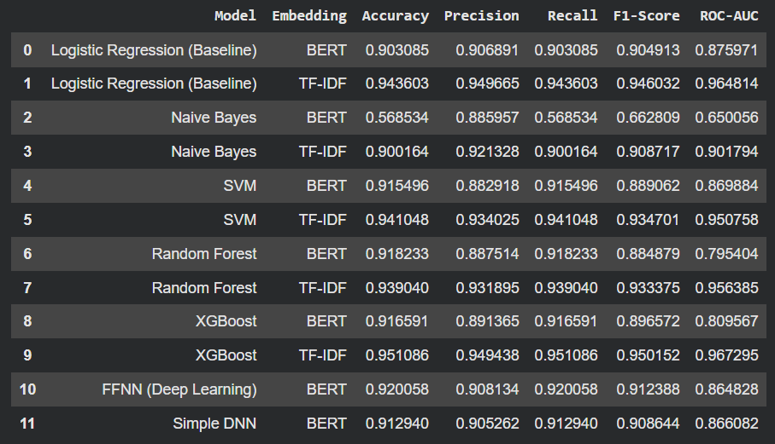

Conclusion & Future Work
This study developed an integrated framework for detecting AI-generated Arabic text using a combination of stylometric and embedding-based approaches. Comparative experiments showed that TF-IDF features were particularly effective for traditional machine-learning models, while BERT embeddings enhanced generalization in deep-learning architectures. Among all tested algorithms, XGBoost with TF-IDF achieved the best overall performance (Accuracy = 95.1%, F1 = 0.950), demonstrating an optimal balance between accuracy, interpretability, and computational efficiency.
The linguistic and statistical analyses confirmed distinct stylistic differences between human-written and AI-generated Arabic texts — the latter being generally shorter, more repetitive, and structurally consistent. These findings validate the effectiveness of automated Arabic AI-text detection and highlight its importance for maintaining content integrity in the era of large language models.
For future research, the framework could be expanded to include cross-domain and cross-model evaluations for stronger generalization, integration of dialectal and social-media Arabic for broader coverage, and fine-tuning of transformer-based models to enhance contextual and stylistic discrimination.

